

REPORT CREATION – TECHNICAL LLD

This document has been approved by

|  |  |
| --- | --- |
|  |  |
| IFS Business consultant | Customer Solution owner or accountable role |
|  |  |
| Date | Date |

Document Revision History

|  |  |  |  |
| --- | --- | --- | --- |
| Revision | Date | Author | Remarks |
| A1 | 2023-12-19 | DILIP | I have started the Technical LLD document creation and will be submitted for review to the team. |
|  |  |  |  |
|  |  |  |  |
|  |  |  |  |
|  |  |  |  |
|  |  |  |  |

Table of Contents

1 Report Creation Purpose and Guideance 4

2 Open Issues/Decisions Required on MVP Phase 2 4

3 Business Requirements and References 4

4 Solution Description 4

4.1 F unctional Requirement and Prerequisites 4

4.2 Functional Solutions 4

4.2.1 List of assign Jira Issues 4

4.2.2 Details page of Jira Issues 4

4.2.3 Action Items 4

4.2.4 Statistics 4

4.3 Development Solution 4

4.3.1 Functional Requirement and Prerequisites 4

4.3.2 Functional Solution 4

4.3.3 Development Specification 4

5 User Flow Digrams 4

6 Wireframes 4

# REPORT CREATION PURPOSE AND GUIDANCE

This component introduces an interface to create preliminary reports for Expert Advisory Menu Card Services. This tool will take a Jira Issue ID as input and automatically gather essential information from various sources such as Jira, Service Now, SharePoint, Power BI and the IFS Digital Assyst database to generate a draft of the final report.

The draft is based on the final report template. When a new template is created Project Team needs to be notified of the new report template. The project team will take in the new final report template and do the necessary adjustments to make it compatible with Report Creation tool. The report creation tool will pick the latest available final report template from its own repository that is managed by the project team.

**This tool will only create the final report draft and mention the data that will be placed in the draft automatically.**

# OPEN ISSUES/NOT INCLUDED IN MVP

This specification cannot be completed until the following issues/decisions have been resolved:

|  |  |
| --- | --- |
| Issue/Decision | Description |
| How to get Customer Participants | As of now we are getting this information from comments posted on Jira, but this is not only way we are communicating with the customer, but we are also using outlook and calendar to do the communication within the customer team, we need to find the way how we can get those participants as well. |
| Customer Logo | Currently is hard to get the logo from Jira because it’s not added there, Jira using default Icon, if we upload the logo, Jira will reduce the logo size |
| Objective of Service | This is the Jira description, that we need to add into the Document in Phase 2 |
| Remove Section from Template | If the user does not want a specific section, then they should be able to remove that. |
| MS Macro | Once experts complete the draft, including their Observations and Recommendations, a Microsoft Word Macro will enable the user to upload the file back to the system. IFS Digital Assyst – Report Creation extracts key details for its database and uses AI-powered NLP to create an executive summary. After review and adjustments, the summary will become part of the report.  Experts can then thoroughly review the final report before submitting it for approval. Upon approval, the report is attached to the relevant Jira Issue, accompanied by a brief note confirming its completion and attachment. The approval mechanism should also be a part of IFS Digital Assyst – Report Creation Component. |
| Statistics | When user land on all assign Jira issue page, they will be able to see two tabs one is “**Assign Jira issues**” and another “**Statistics**”, after click on 2nd tab they will be move to 2nd tab content, under this section we will show the complete information about ongoing and complete reports |

# BUSINESS REQUIREMENTS AND REFERENCES

* Interface for creating preliminary reports for Expert Advisory Menu Card Services.
* Input: Jira Issue ID.
* Automated gathering of essential information from various sources (Jira, Service Now, SharePoint, Power BI, IFS Digital Assyst database).
* Draft report generation based on the final report template.

# SOLUTION DESCRIPTION

## FUNCTIONAL REQUIREMENT AND PREREQUISITES

Under this module the user can see all Jira issues that are assigned to them and if the Jira issue is open, they will be able to create the basic skeleton of the final report based on the template. If it is closed, they can see the reports that have been created for each issue.

By using Jira and other various sources (Service Now, SharePoint, Power BI and IFS Digital Assyst database), users can collect mandatory information to create the final report draft.

**API and Azure AD account authentication.**

|  |  |
| --- | --- |
| Azure AD Authentication | Azure AD will help to fetched user basic information such as Name, Email, and Designation etc. |
| API | This should be a two-way integration. We gather info. Then we should have the ability to submit the completed report to Jira. |

## Functional Solutions

This section explains each functional activity within the report creation module under the report creation module there are multiple screens that help to complete the process, here are a list of all pages:

* **List of Assigned Jira Issues**
* **Detail page of Jira issue**
* **Action Items**

### LIST OF ASSIGN JIRA ISSUES

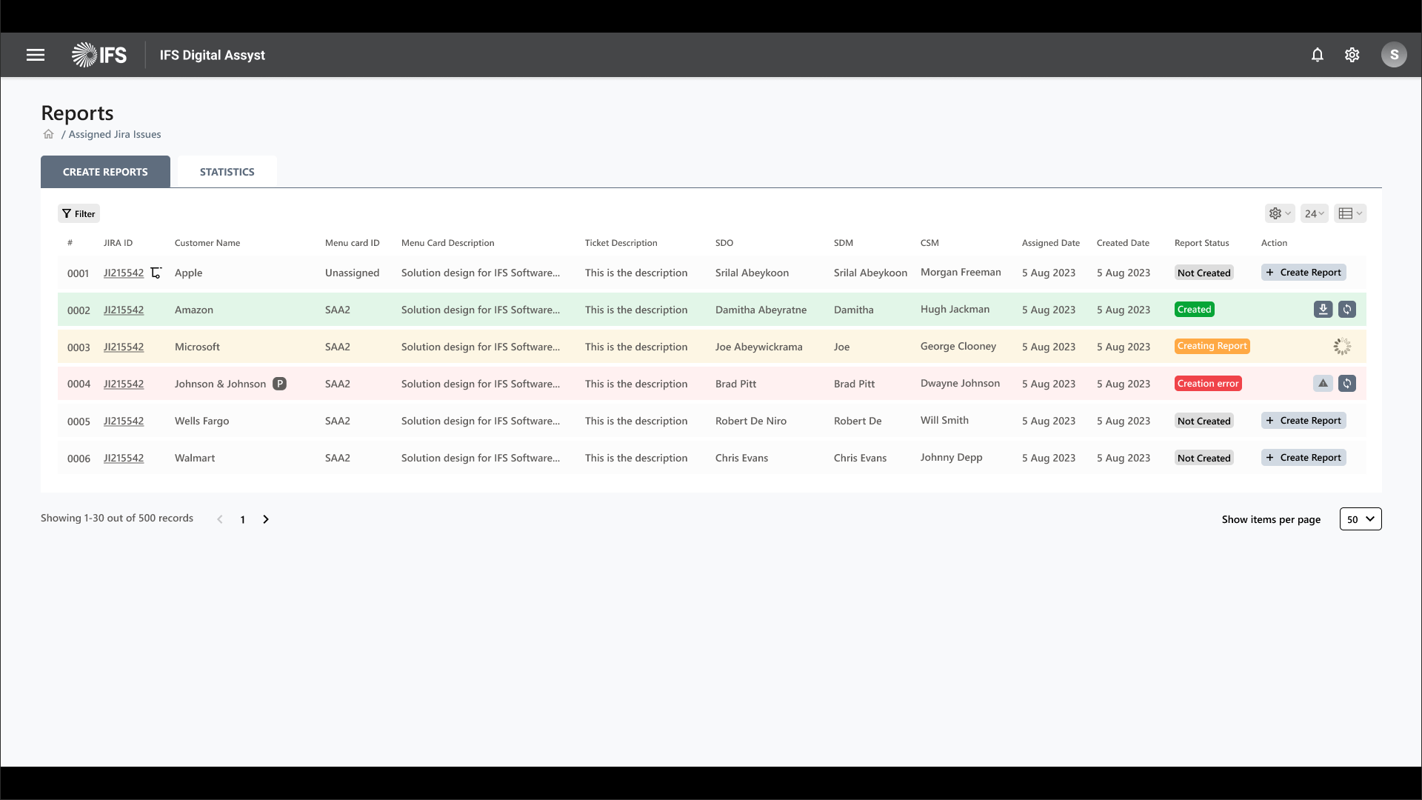

The logged in user will see all the assigned tickets on this page, this data will be provided by Jira, user can create the report one by one under each item tickets).

*Page Content: Below table will explain each content area of this page:*

|  |  |  |  |
| --- | --- | --- | --- |
| Column Name | Description | Data Source | Data Type |
| Item ID | This is a system generated id, that will give a unique identification of each records item | System Generated | string |
| Jira ID, Sub Task | This ID will come from Jira, and contain complete information about customer and Ticket, that is associated with. | Jira | string |
| Customer Name | This will be the Project/customer name, API can find it using project ID | Jira | string |
| Menu card ID | Name of menu card Item associate with Ticket, if user not able to find it, they can select it from the item listing | Jira/IFS Assyst DB | string |
| Menu card description | This is the description added by customer to explain the issue or concern | IFS Assyst DB | string |
| Ticket Description | Ticket Description will be posted by customer during ticket creation | Jira | string |
| SDO | Service deliver officer, who is a part of delivery process | IFS Assyst DB | string |
| SDM | Service deliver Manager, who is a part of delivery process and client communication | IFS Assyst DB | string |
| CSM | Customer Service Manager, who is the part of services and approval process. | IFS Assyst DB | string |
| Creator | The person who posts this ticket from Snow | Jira | string |
| Assigned Date | Assigned issue date to an expert | Jira | Date |
| Created On | This is the ticket created date into the Jira system | Jira | Date |
| Report Status | Nder the status column user able to see the present state of the items following is the status name:   |  |  | | --- | --- | | Not Created | Report is not created yet | | Created | Report Created and able to download | | Creating report | Report Creation is in process | | Creation error | System found error during the report creation process | | IFS Assyst DB | String |
| Action | Under this column, there are few action buttons: View details, create report, and delete | IFS Assyst DB |  |

### DETAILS PAGE OF JIRA ISSUES

This page will contain complete information about the Jira ticket, following are the content.

areas:

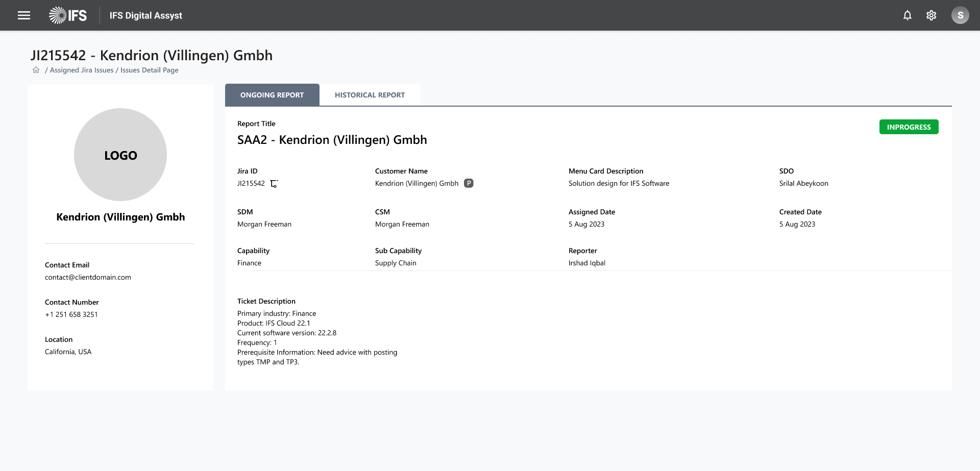

|  |  |
| --- | --- |
| Section Name | Description |
| Title | This will be the name of Ticket |
| Breadcrumbs | Name of all parent pages / Page location |
| Action Button | Create report |
| Tickets Information | This section will contain complete information about tickets, like customer info, service menu card etc. you can see the complete information under 4.2.1 section |
| History Chart | This section contains the complete history of past tickets posted by the client. Users can map current issues with older solutions. |

### Action Items

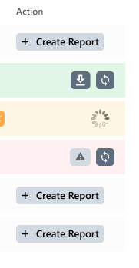

There is multiple action menu with each list items, that helps to configure, file the list of

action items:

|  |  |
| --- | --- |
| Action Name | Description |
| Create Report | When user click on the button, popup will appear and show all the required fields and allow user to change the information if it’s not correct with a confirmation button.  **Popup Content:**   |  |  | | --- | --- | | Item | Description | | Image and title | A relevant image that helps to recognize the purpose of the popup and a title that give an identification of it | | Jira ID | This we get it from Jira and user can’t edit it | | Menu Card | Menu card ID is the identification of the template that we going to use for the appropriate report, some time it’s unassigned, we allow user to select it manually to give a valid identification of the template | | Customer Name | It will get from Jira, and allow user to edit | | Expert | It will get from Jira, and allow user to edit | | Creator | It will get from Jira, and allow user to edit | | Customer Logo | User can upload the logo if it’s not available | | Confirmation Message | This will be confirmation message: “Please make sure you are creating the document for correct Jira ID.”  It will help user to confirm the data with they are proceeding | | Action Button | There are two buttons, one is for canceling the complete process another one for submitting and sending request for next process, next process describe below: |   *When user confirm it, API will automatically start filling the required information into the template and this process will take some time complete.* It’s A SC |
| Download | When user click on the download report button, it will open the popup that shows the status of getting the document from repository/OneDrive location, when it’s complete it will automatically open the MS Doc application with the selected report template |
| Sync | This button will help to get updates from Jira, related to required information |
| Error Icon | This is waning/alert for showing there is an issue with report creation |

## Development Solution

### Functional Requirement and Prerequisites

This section explains each functional activity within the report creation module under the report creation module there are multiple screens that help to complete the process, here are a list of all pages:

* **Home Page**
* **List of Assigned Jira Issues**
* **Detail page of Jira issue**
* **Action Items**
* **Schedular for report creation**

**Home Page:** Home will be landing page of the application. Currently login page redirected to issue listing page. Login page authenticated with Microsoft 365 (Azure login).

**List of Assigned Jira Issues:** This page will show all Jira issue (task and sub tasks) assigned to

Login user. After successful login user can see only their assigned Jira issue. Each listing issue having Create Button to create report. After successful created report a download link available for report.

**Detail Report Page:** Detail page having all details for that Jira key including client details.

**Report Creation:** Report creation is back ground process that will take require input parameter like Jira Key, Menu Card Customer name, Product, Capability , Sub Capability, Client logo and Creator name to generate report.

**Schedular for report creation:**

**Storage of report:**

### User Authentication

To ensure secure access to the Report Creation Tool, Azure AD Authentication will be implemented. Users will log in using their Azure AD accounts, allowing the tool to fetch basic information such as Name, Email, and Designation. This authentication will enable personalized access to assigned Jira issues and streamline the report creation process.

### Data Integration

The system will fetch information related to Jira issues, including Jira ID, Sub Task details, Customer Name, Menu Card ID, Menu Card Description, Ticket Description, SDO (Service Delivery Officer), SDM (Service Delivery Manager), CSM (Customer Service Manager), Creator, Assigned Date, Created On, and Report Status.

### Report Creation

The Report Creation Tool will provide a user-friendly interface with the following key functionalities:

**List of Assigned Jira Issues**

Users can view all Jira issues assigned to them, differentiating between open and closed issues.

**Detail Page of Jira Issue**

On the detail page, users can access comprehensive information about a specific Jira issue, including Action Items and associated details.

**Action Items**

For each Jira issue, the tool will display Action Items with relevant information, including:

* **Item ID:** Jira key unique identification for each record item.
* **Jira ID, Sub Task:** Jira-generated ID containing complete information about the customer and ticket.
* **Customer Name:** Project/customer name retrieved using the project ID.
* **Menu Card ID:** Name of the menu card item associated with the ticket.
* **Menu Card Description:** Description added by the customer to explain the issue or concern.
* **Ticket Description:** Description provided by the customer during ticket creation.
* **SDO (Service Deliver Officer):** Involved in the delivery process.
* **SDM (Service Deliver Manager):** Involved in the delivery process and client communication.
* **CSM (Customer Service Manager):** Part of services and approval process.
* **Creator:** Person who created the ticket in Snow (Service Now).
* **Assigned Date:** Date the issue was assigned to an expert.
* **Created On:** Date the ticket was created in the Jira system.
* **Report Status:** Indicates the present state of the item, with options like "Not Created," "Report Created and Able to Download," "Creating Report," and "Creation Error."
* **Action:** Buttons for View Details, Create Report, and Delete actions.

#### **Additional Features**

* **Subtask Item Description:** Include subtask item description for clarity, specifically for menu card descriptions.
* **Updated/Refreshed Status:** Consider adding a status to identify if the record is "Updated" or "Refreshed," aiding in history logs.
* **History Logs:** Implement a feature to track changes and updates, providing a comprehensive history of actions taken on each record.

### Functional Solution

The Report Creation Tool will be developed using the following technologies:

* **Backend API:** Django
* **Frontend:** React (with Vite)
* **Database:** MySQL
* JIRA API

### Backend (PYTHON/Django)

Django will be the backend framework, providing the necessary APIs to fetch Jira issues assigned to the logged-in user and other relevant data from the database.

### Frontend (React with Vite)

The frontend will be developed using React with Vite as the build tool. MSAL (Microsoft Authentication Library) will be implemented for secure login, ensuring a seamless and secure authentication process.

### Database (MySQL)

MySQL will serve as the database for storing master data, including information about SDO, CSM, SDM, projects, customers, and menu cards.

### **Authentication Flow**

1. Users access the Report Creation Tool.
2. Azure AD authentication is initiated.
3. Upon successful authentication, users gain access to the tool with their personalized information.

### **API Integration**

1. Django APIs fetch Jira issue details and relevant data from Service Now, SharePoint, Power BI, and IFS Digital Assyst Database.
2. APIs provide necessary information for frontend rendering.

### **Frontend Development**

1. React with Vite is used for frontend development.
2. MSAL is implemented for secure login and user authentication.
3. User interface components include the List of Assigned Jira Issues, Detail Page of Jira Issue, and Action Items.

### **Database Schema**

1. MySQL database stores master data, including information about SDO, CSM, SDM, projects, customers, and menu cards.
2. Tables are designed to establish relationships and ensure data integrity.

### **Report Creation Process**

1. Users interact with the tool to view assigned Jira issues and navigate to the detail page.
2. Action Items are displayed with relevant information.
3. Users can perform actions such as viewing details, creating reports, and deleting items.

### **Version Control and Deployment**

1. Git will be used for version control.
2. Continuous integration and deployment (CI/CD) pipelines will be set up for efficient development and deployment processes.

### **Development Specification**

Login Page

Currently home page issue

Home Page

Header and Top Nav

List Report Page

React application : information listing page with screenshots

Jira API going to call

Database information

Python

This four part will repeat for each page/functional.

Detail Report Page

React application : information listing page with screenshots

Jira API going to call

Database information

Python

This four part will repeat for each page/functional.

Report Creation

Schedular for report creation

Storage of report

##### Reports and tools

|  |  |  |
| --- | --- | --- |
| Report name | Report layout tool | Comments |
|  |  |  |
|  |  |  |

##### Layout

Guidance: Report development requires close collaboration with the customer to make sure the requirements are captured in detail. It is recommended to do final layout check together with the customer before implementation. Include an illustration or picture of the existing report or a data drawing of how it should look. If this is an upgrade and the layout in the upgraded version is supposed to be identical to the old one, you can use a scan from the customer. Specify any special considerations for first page, repeat section, last page and paper size. Specify headers and footer. Specify logo, page numbers. Specify fields to be added or removed. Specify fonts and field format (for example date format: <dd.MM.yyyy> and number format: <9 000 000,00>)

##### Data extract

Guidance: Specify logical data blocks such as Order Head and Order Lines, Field mappings and format. Specify fields in the application, If applicable specify formulas to use if calculations are necessary etc. Which data sources (Entity diagrams from Developer Studio is great, and/or screenshots of IFS Applications with marked fields).

##### Ordering

Guidance: Specify Input parameters, manual or automatic ordering and navigator position. Define requirements for printing the report

##### Output Management

Guidance: Define special considerations when it comes to selecting printer etc.

# User Flow Digrams

This is the user flow where each step is described:  
URL: <https://www.figma.com/file/RzLf5VlNZzDUbZxfbDcNwn/Generate-Report?type=whiteboard&node-id=721-2846&t=rqVhJ5bbg4pmKvX3-4>

# Wireframes

There are the basic design of application applications, below is the URL:  
https://www.figma.com/proto/uF0dsb0l8qLHXY1JnYRou4/Design-Master-File?page-id=0%3A1&type=design&node-id=441-1536&viewport=-1027%2C-3093%2C0.55&t=bvGdUgqWRnrX1LLB-1&scaling=min-zoom&starting-point-node-id=102%3A269&mode=design